**Describing a picture:**

|  |  |  |
| --- | --- | --- |
| at the top left-hand  in the top left (of) | at the top (of) | at the top right-hand  in the top right (of) |
| on the left  next to… | http://zappenglish.com/wp-content/uploads/2013/02/2.9_English_Vocabulary_Describing_Appearance.jpg | on the right  in the middle (on the right)  down to the right |
| down to the left  at the bottom left  at the bottom-left corner… | at the bottom (of) | at the bottom right  at the bottom right-hand |

in the upper / in the picture/image/photograph at the top

in the upper part of the picture, there is..

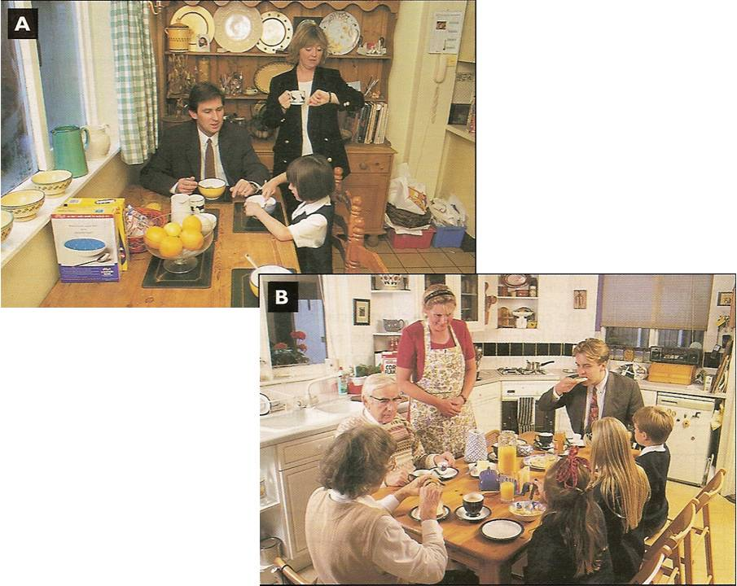

In the lower / in the picture at the bottom /image/photograph

in the lower part of the picture